William Meyer, Maurice Wilson, and Justin Apostle

CMSC 495

1/29/2022

**User Guide**

**Browser and access**

Access the website through a modern web browser like Google Chrome or Mozilla Firefox by entering the website url below:

[website url TBD]

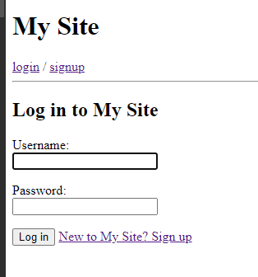  
*Figure 1*. Homepage for website.

**Account Creation**

The user will be directed to a login page with a button to create a new account. New users will need to create an account to access website functions.

Password complexity is a must on account creation. The user will need to create a username and the password must be longer than 8 characters with an upper case, lowercase, number, and symbol for optimal security.

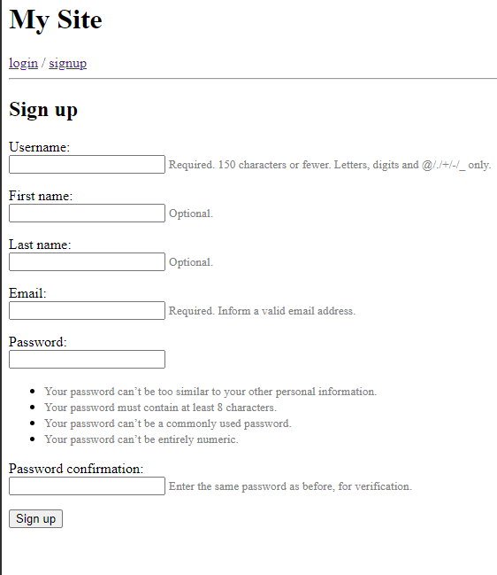  
*Figure 2*. Account creation page.

After account creation, the user will be redirected to the login page.

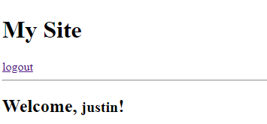  
*Figure 3*. Successful login prompt.

**Account Login**

The user will enter their username and password to login to their account.

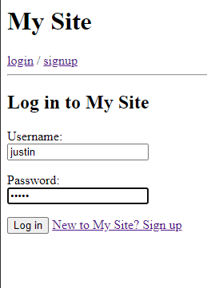  
*Figure 4*. Login page.

If the password or username is entered incorrectly, an error will be displayed that one or both are incorrect. After 5 failed logins, the user will be unable to login for 1 minute.

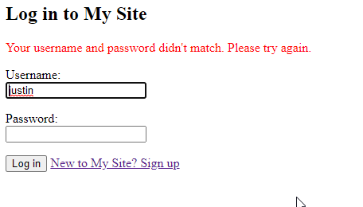  
*Figure 5*. Error prompt from failed login.

**User Dashboard**

Upon logging in, the user will be prompted to their dashboard. From here, the user can select an existing project or create a new project to build upon.

**Creating a New Project**

When creating a new project, the user will be prompted to fill several fields to include Project Name, Type, and expected Completion Date. Each field must have an entry and can be edited by the user after creation. The user will then select “Create” project.

**Project view**

Once in a project, the user will have four standard columns detailed “Tasks to Do”, “Tasks in Progress”, “Tasks on Hold”, and “Completed Tasks”. The user can elect to create new containers in each column to start building their tasks and workflow by selecting “Add Task” at the bottom of each column.

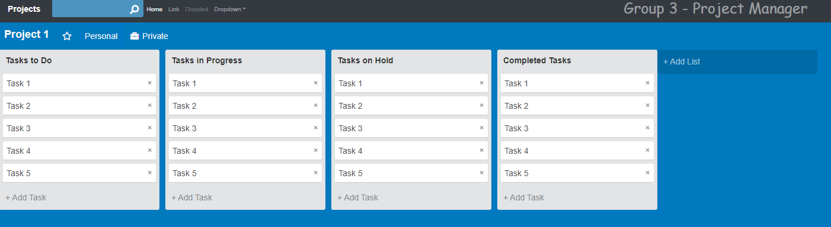  
*Figure 6*. Project view.

**New Task Creation**

The user can select which column to push the container to, the title of that task or objective, and any additional details they would like to include. Once done, the user will then select “Create” in the bottom right corner.

  
*Figure 7*. Add task button.

**Column Management**

Besides the 4 columns that are standard on the project view, the user can include additional columns if their project requires it. Select the “Add List” button next to the current columns. “Add List” has similar parameters to “Add Task” but also includes where it will fall in the list of columns. Lastly, the User can also edit each column by selecting the ellipses on that specific column, selecting edit, and editing the title and position of the column.

  
*Figure 8*. Add a column.

**Task Management**

Like the columns, tasks can also be managed by dragging and dropping where they fall in a column. Additionally, there is a delete option for the task, upon selection the user will be prompted to confirm they would like to delete the task.

  
*Figure 9*. Deleting tasks available with ”x”.

**Returning to Dashboard**

The user can return to the dashboard from any project at any time by selecting “Projects” in the top left.

  
*Figure 10*. Return to dashboard view with ”Projects”.

**Managing Projects**

The user can manage their project view in the dashboard by selecting edit on the project. From here, the user can select if the project is “In Progress” or “Completed” which will also change the color of the project. From the edit view, the user can also delete the project and will be prompted in the same manner as Task Management.

**Logging Out**

At any time, the user can logout in the top right corner with the “Logout” button. The user will be prompted to ensure they would like to logout. After logging out, the user will be sent back to the original login page.

  
*Figure 11*. Logout button.

**Test Plan**

**Approach**

The test plan aims to confirm the identified functionality of the web application. Developers of the web application will conduct each of the test cases to ensure the web application functions properly. The developers will address any issues found while testing functionality. Additionally, the developers will improve the application based on feedback from testing to ensure an optimal user experience.

**Functionality**

* Account creation
* Access functionality
* Dashboard functionality
* Project creation and removal
* Task creation and removal

|  |  |  |  |
| --- | --- | --- | --- |
| **TC** | **Input** | **Expected Output** | **Pass?** |
| Test Case 1: Account creation | Select “Create Account”  Enter suitable Username  Enter suitable Password | The user should navigate to the website and select “Create Account”. From there, a suitable username and password will allow the user to create an account. |  |
| Test Case 2: Account validation | Login using Username and Password  Logout | The user will enter previously created username and password. Once logged in successfully, the user will then logout confirming account validation. |  |
| Test Case 3: Dashboard functionality | User logs in  Dashboard view populated  Project Selected | The user will log in to their account and directed to the dashboard. From the dashboard, the user can view all projects created and select one to view. Once selected, the project will populate with all created tasks and columns. |  |
| Test Case 4: Project creation | User selects “Create Project”  User enters Project name, type, and completion date  User selects “Create”  View newly created project | From the dashboard, the user will select “Create Project” and populate the appropriate fields. Once completed, the user will select “Create” which will create the project and populate the newly created project at the top of the project list. Upon selection, the project will populate with the standard columns and tasks. |  |
| Test Case 5: Delete project | User selects ellipses next to the project  User selects “Edit”  User selects “Delete project” and confirms | From the dashboard, the user will identify a project to be deleted and select the ellipses of the project. From there, the user will select “Edit” and be redirected to a page to edit the project. The user will select “Delete project” and confirm. Once deleted, the user will be redirected to the dashboard and the project identified will no longer be on the list of projects. |  |
| Test Case 6: Task creation and assignment | User will select a project  User will select “Create Task”  User populates information and selects “Create”  User can then drag and drop task to test functionality | The user will select a project from the dashboard. Inside the project view, the user will select “Create Task” and populate appropriate information. The task will be created in the column identified by the user. The user can then test drag and drop functionality by left click and holding then releasing on a different column. |  |
| Test Case 7: Delete task | User will select a project  User will identify and delete a task from the project view | The user will identify and select a project from the dashboard. From the project view, the user will again identify a task and select the “x” next to the task. The user will be prompted to confirm the action. Once confirmed, the task will be removed from the project. |  |

*Figure 12*. Test cases for the application.

**References**

University of Maryland Global Campus. (2022). Homepage for website [screenshot].

University of Maryland Global Campus. (2022). Account creation page [screenshot].

University of Maryland Global Campus. (2022). Successful login prompt [screenshot].

University of Maryland Global Campus. (2022). Login page [screenshot].

University of Maryland Global Campus. (2022). Error prompt from failed login [screenshot].

University of Maryland Global Campus. (2022). Project view [screenshot].

University of Maryland Global Campus. (2022). Add task button [screenshot].

University of Maryland Global Campus. (2022). Add a column [screenshot].

University of Maryland Global Campus. (2022). Deleting tasks available with ”x” [screenshot].

University of Maryland Global Campus. (2022). Return to dashboard view with ”Projects” [screenshot].

University of Maryland Global Campus. (2022). Logout button [screenshot].

University of Maryland Global Campus. (2022). Test cases for the application [screenshot].